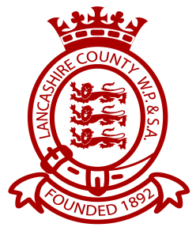 LWPSA JUNIOR MEET 2016
Licence No. 3NW161064
PROGRAMME OF EVENTS

SESSION 1 SATURDAY 2 JULY 2016 SESSION 2 SATURDAY 2 JULY
WARM UP 8:30 A.M. START 9:30 A.M. WARM UP P.M. TBC

Event 101 Girls 100m I.M. Event 201 Boys 100m I.M.
Event 102 Boys 50m Fly Event 202 Girls 50m Back
Event 103 Girls 50m Fly Event 203 Boys 50m Back
Event 104 Boys 100m Breast Event 204 Girls 100m Free
Event 105 Girls 100m Breast Event 205 Boys 100m Free
Event 106 Boys 50m Free Event 206 Girls 50m Breast
Event 107 Girls 50m Free Event 207 Boys 50m Breast
Event 108 Boys 100m Back Event 208 Girls 100m Fly
Event 109 Girls 100m Back Event 209 Boys 100m Fly
Event 110 Boys 8 x 50 Cannon Event 210 Girls 8 x 50m Cannon
(2 from each age group swum in any order) (2 from each age group swum in any order)

