TOWEL £20 CAPS £7
We are pleased to offer these bespoke Lancashire County towels and swimming caps which are only available to order prior to the County Championships. Please complete and return the club form below to: Garry Whittle Age Group Secretary, 51 Heron Way, Blackpool FY3 8FA
Tel: 01253 393967 E Mail gmwhittle51@gmail.com and make cheques payable to: Lancashire County WPSA by December 14th 2016. All products ordered will be available for club collection at Manchester Aquatics from 28th January 2017.

--------------------------------------------------------------------------------------------------------------------------------------
Name of Club:___________________________________________________________
Club Contact : ___________________________________________________________
Telephone:_____________________________________________________________
Email : _________________________________________________________________
 | Towels £20 | Caps £7
Total Quantity
Total Cost
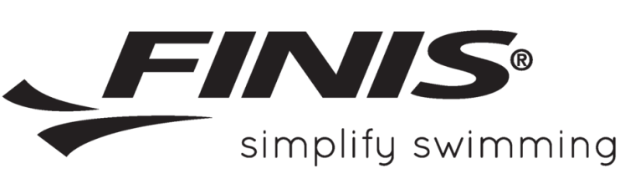
*Please return forms and cheques to Garry Whittle by December 14th 2016

